|  |
| --- |
|  |



**10 May 2013** **The Weekly Bulletin of Rotary Club of Kathmandu Mid-Town** **Bc-10.5/012-13**

**District : 3292 Web: www.rotarymidtown.org.np Club Id : 26776**

**MAY : Month Without Any Specific Theme**

**Except July and May, all other months of a Rotary Year carry specific themes.**

Friday, 12 April:

**4th Club Assembly**

AG Dr J. L. Amatya in the process of conducting the Club Assembly requested different committee chairs

to present progress reviews of their respective avenues.

Club Administration Chair Paras Sumsher JB Rana, Membership Development Chair Dr Isabella Khadka Public Relations Chair Lisa Chogyal, TRF Chair Rabi Karmacharya, Service Projects Chair PP Ajaya Sthapit and New Generation Chair Dr Chandra Lekha Tuladhar presented reportings on avenue-specific activities and programs.

President Devendra thanked AG JL Amatya for conducting the Club Assembly and for his positive and inspirational remarks.

Friday, 19 April:

The Club had a very prominent Neurological Surgeon,

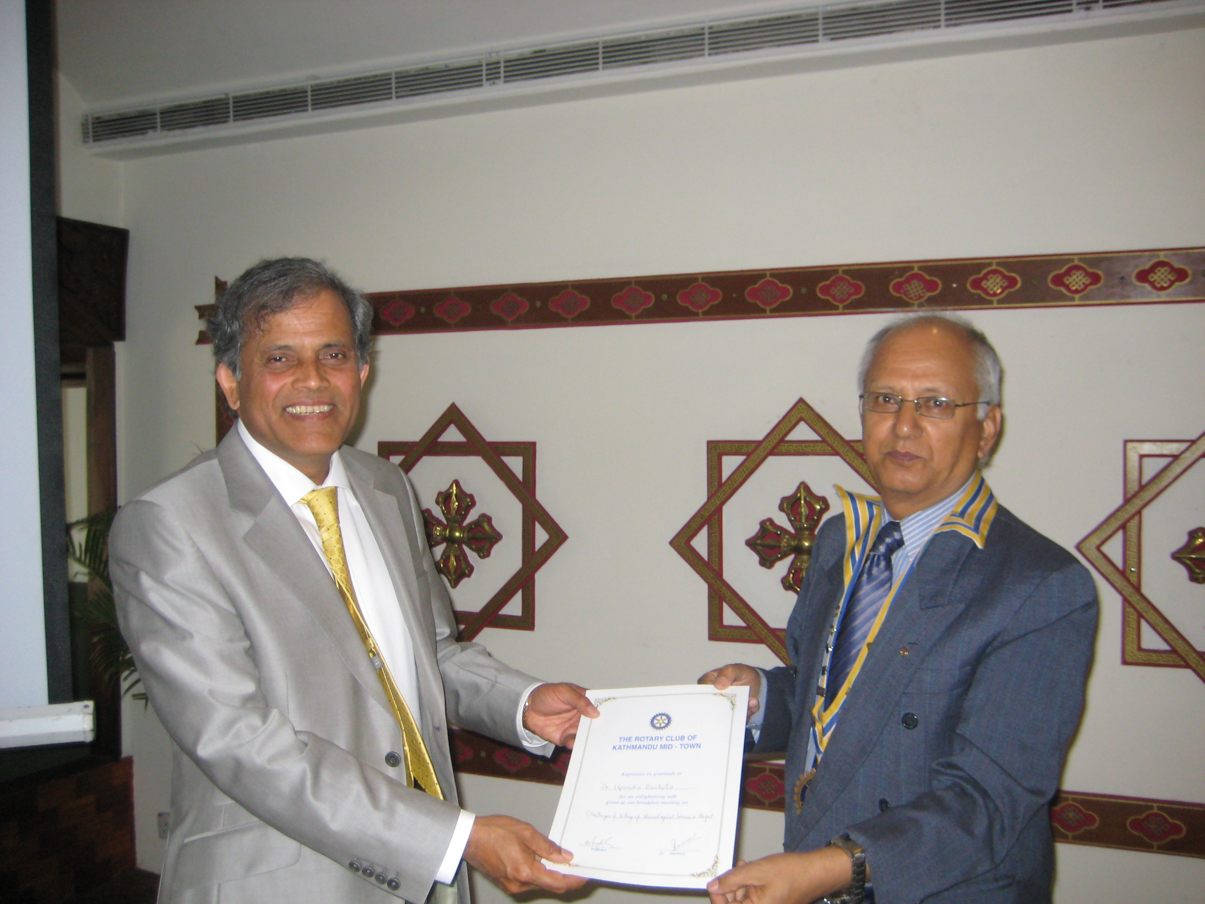

Dr Upendra Devkota, as the Guest Speaker for the day.

He gave a very interesting talk on the topic "Challenges

of Setting up Neurological Services in Nepal". Neurology,

he said is not getting appropriate and justified concern

in Nepal as compared to cardiology and cancer. He

recalled that the *n*eurological treatment was formally

started in Nepal by opening a section in Bir Hospital when

there were mere two or three neuro-surgeons in the

country. Organized head injury service was started from

1989. Now with his effort, a reputable Neurological

Hospital is running in Kathmandu with state of the art

equipments. He emphasized that in head injuries, delay

in treatment is synonymous to death. He also stressed that

good medical service in neurology demands 24 hour

attention from the doctors.

Friday, 26 April:

In-house Speaker Rtn Rabi Karmacharya presented on how technological advancements can be used to improve access to quality education in rural schools in the country. He emphasized the need for a comprehensive effort from the stakeholders including the government to prepare relevant content, develop teachers' skills and confidence, and build local capacity in order to successfully use computers in schools to promote student learning. He shared few innovative work going on in Nepal, and also gave a demonstration of a digital library ([www.pustakalaya.org](http://www.pustakalaya.org)) that was developed and maintained by OLE Nepal.

Friday, 3 May:

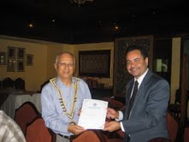

Dr. Chudamani Joshi, a graduate in Plant Science, Legislative Law, Natural

Resource Management, and PhD in Tropical Forest Ecosystems, was Guest

Speaker for the day. Dr. Joshi has been working with the Embassy of

Finland in Kathmandu since 2009 as a programme coordinator and

responsible for forestry, climate change and environment sector

programme. Dr. Joshi gave a presentation on ‘Boom in Broom Grass:

Nepal Leasehold Forestry programme’. He gave a brief description on

how with the technical help of the Government of Finland, a leasehold

forestry program was implemented in Palpa, Syanja, Gulmi and Nawalparasi districts of Nepal.

Plantation of fuel-wood trees, fodder grass, fruit species and specifically promotion of broom grass

in mass scale changed the economic status of the poor hilly people on one hand and rehabilitated the

degraded forests. Impact of this programme among others improved the livelihood of the people and

helped in women’s full participation in group activities. He also refered the future plan of the local

people to develop Jhirubas-Hupsekot corridor based on this programme.

# Weekly Meetings and Programs :

|  |  |  |
| --- | --- | --- |
| Date | Program/Speaker | Program/Topics of Presentation |
| 10 May 2013 | Colin Holmes, Program &Officer, USAID | The Pursuit of Happiness |
| 17 May 2013 | Dr. Bhai Kaji Tiwari, | District Commissioner |
|  |  |  |

Friday, 10 May:

Rtn Colin Holmes, Program and Project Development Officer, USAID/Nepal,

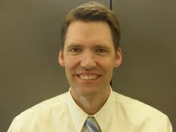

will be our Guest Speaker for the day. He will be talking on an interesting topic "The Pursuit of Happiness." He will try to define happiness and discuss some interesting findings about what it is and how to obtain it. He is presently a member of the Rotary Club of Capitol Hill in Washington DC.

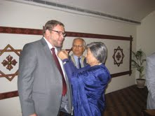

**New Member Induction**

HE Asko J Luukkainen, Finland Ambassador to Nepal,

was inducted to the Club as a new member during the

regular meeting on 19 April 2013. PP William Ma

administered the Induction program while PP Giridhar,

PP Arun and PP Subarna assisted in specific items.

PP Ambica provided Asko Rotary Pin. President Devendra

congratulated newest Rotarian Asko and welcomed him

to the Club. A warm welcome was provided to him by

all Club members present on the occasion.

PP Ambica providing Rotary pin to Rtn Asko

**Two New RCC's of the Club:**

President Devendra, during regular weekly meeting on 5 April 2013, informed that Rotary International approved the formation of RCC Gorkha (Sooryapal Village Improvement Committee), and RCC Lamjung (Samaj Sudhar Kendra Dhuwankot). It was the result of ceaseless effort of late PP Pratap Malla for whom unfortunately, receving certificate from RI was too late.

**Visiting Self Help Group for Cerebral Palsey:**

On 5 April Friday morning, after the regular meeting, a few Mid-Towners visited the Self Help Group for Cerebral Palsey in Dhapakhel to witness handing over of funds to support the acquiring of a vehicle for the SGCP, a program of the Rotaract Club of Kathmandu Mid-Town. Rotaract President Kishor Acharya and PE Gautam were on hand to welcome guests. **His Excellency Frank Meyke,** a Mid-Towner, graced the function as chief guest.

SGCP Chairperson B Rajbhandari gave a short background of the Centre. The presentation was followed by a few words from **Prof Gunter Gross-Selbeck**,(Neuro-Pediatrician/Germany) who explained his continued involvement with the Centre over the past ten years from where they first started in a few rooms in Baneshwor,to buying the land and building the wonderful modern building that they now have. Prof. Gross-Selbeck's commitment is inspiring and he and his wife are seriously committed to seeing this project through for the long term. HE Frank Meyke appreciated the work that had been done and he handed over a check for **3000€** (Rs 3,34,656) from the **RC Landshut** (District 1840) to SGCP Chairperson Mr. B Rajbhandari. These funds will be used as a contribution towards a vehicle which is seriously needed for the Centre to be able to transport children to and from their homes.



A photo-session after the program

*courtesy:* Rtn Dr Isabella C Bassingana Khadka

**Council on Legislation decisions:**

Delegates from Rotary’s 532 districts gathered in downtown Chicago 21-26 April to consider changes to the policies that govern Rotary International and its member clubs.

The Council on Legislation meets every three years to debate proposals submitted by Rotary clubs, districts, and the RI Board of Directors. The Council has the power to pass resolutions and to make changes to the Constitution of Rotary International, Rotary International Bylaws, and the Standard Rotary Club Constitution.

The 174 pieces of legislation being debated during this year’s Council were received at Rotary headquarters by the due date of 31 December 2011.

The CoL delegates approved:

- a US$1-a-year increase in per capita dues that clubs pay to Rotary International, starting in 2014-15. The increase was proposed by the RI Board based on a [five-year financial forecast](http://www.rotary.org/RIdocuments/en_ppt/col13_five_year_financial_forecast_en.pptx) presented to the Board last week and shared with delegates on Sunday. According to the forecast, if there were no dues increase, RI’s deficit would grow to $9 million in 2018 and reduce the General Surplus Fund below the level required in the RI Bylaws.With the dues increase, the deficit will fall to $5 million in 2018, according to the forecast, and the surplus fund will then stand at $88 million, above the mandated level.

- a measure creating the office of vice governor, who would fill in if the governor becomes unable to serve. The vice governor would be selected by the district's nominating committee from among the district's past governors.

- increasing the number of clubs that can take part in pilot projects to 1,000, up from the previous limit of 200.

- a measure allowing Rotarians outside the United States and Canada to receive an electronic version of their official  Rotary regional magazine if one is available.

- changing the name of Rotary’s Fifth Avenue of Service, currently called New Generations, to Youth Service. The 2010 Council on Legislation approved this avenue of service for youth, which joined Rotary’s Four Avenues of Service (Club, Vocational, Community, and International). The name New Generations was meant to reflect the need to build up the next generation of Rotarians, but proponents of the name change argued on Wednesday that the word “youth” is more universally understood, both inside and outside Rotary, and clarifies the fact that these programs encourage Rotarians to empower youth.

- allowing a district to have an unlimited number of e-clubs, removing a previous restriction of two e-clubs per district. E-clubs meet electronically, conduct service projects, and sometimes also hold in-person meetings.

- a measure, aimed at increasing membership, that provides for satellite clubs, whose members meet at a different time and location from their parent club but who are also considered members of the parent club.

- a measure allowing participation in club projects to count toward club attendance requirements. The measure amends the Standard Rotary Club Constitution to provide that a member must attend or make up at least 50 percent of club regular meetings or engage in club projects for at least 12 hours in each half of the year, or a combination of both.

- resolutions asking the Board to consider allowing grandchildren of Rotarians to be eligible for Rotary Foundation programs, and to waive the rules for Rotary grants so that family member of Rotarians affected by a natural disaster would be eligible.

- removing the travel reimbursement policy from the RI Bylaws. This will enable the RI Board of Directors to develop a policy that is flexible, able to address emergency travel situations, and able to take advantage of cost-saving opportunities.

- defeating two measures that would have allowed clubs to meet less frequently. The delegates also rejected a measure that would have allowed a club to cancel six regular meetings a year instead of four, for holidays, the death of a club member, disasters, or other emergencies.

*courtesy:* *Rtn Rabi Karmacharya, Chairperson, TRF Committee*

**Committee Chairpersons' Column:**

**???**

**Past Presidents' Column:**

**???**

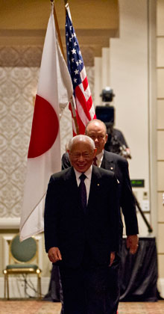

Rotary brings peace by addressing the needs that cause conflict: the need for clean water, for

nutrition, sanitation, and health care. When these needs are met, there is opportunity. And

there is hope. Hope has no borders. It is the garden from which peace can grow. .

**RI President Sakuji Tanaka**

On Mother's Day :

Click here ⇩



On the Occasion of Mother's Day:

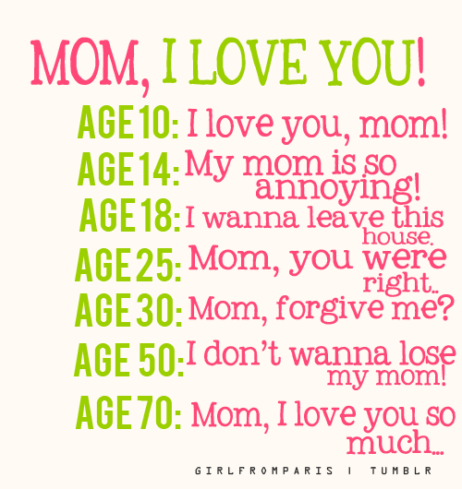

NB: Send any informations/photos that may be of interest to the Club or Rotarians in general to

BC Editor: RR Shrestha email: rryesrr@gmail.com

## 10 May 2013 The Weekly Bulletin of Rotary Club of Kathmandu Mid-Town bc-10.5/012-13